Dear Friend:

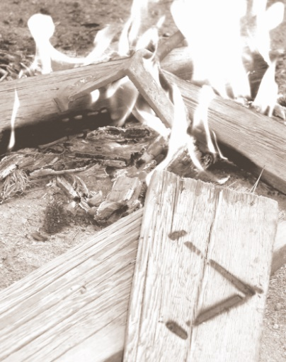

of decision

a

PLACE

IRONWOOD

Howdy from Ironwood Christian Camp! Ironwood is located in southern California and serves churches all across the southwestern United States. Each week we see nearly 300 children at camp and about 10% of our campers will accept Christ as their personal Savior while at camp this summer. Countless others will make important steps of growth in Christlikeness and make other life-changing decisions. You can find out more about us through our website [www.ironwoodcamp.org](http://www.ironwoodcamp.org). We believe that a summer of ministry will continue preparation for a lifetime of ministry for the young person who sent you this letter. We know from past experience that this ministry opportunity will forever impact each staff member. Among the most important life changing decisions made at camp this summer will be those made by our summer staff. Our intensive staff training is a time of preparation and instruction. Emphasis will be placed on knowing and applying God’s Word in all areas of life and on the components of biblical counseling. During the eight weeks of camp, they will see God work miracles in the lives of campers and be used by God in this amazing process.

We have asked our summer staff to present their ministry opportunity to as many people as possible. In order to help them share this opportunity with you, we have a variety of information available on our website, YouTube channel ([www.youtube.com/user/IronwoodOnline](http://www.youtube.com/user/IronwoodOnline)), and Facebook page ([www.facebook.com/campironwood](http://www.facebook.com/campironwood)) which communicate our goal of providing a setting where the preaching of God’s Word and the prompting of the Holy Spirit can take place without distraction. Let me encourage you to participate in your friend’s ministry this summer; there are several ways of doing so. They will need as many people as possible to uphold them in prayer. We have prepared some pledge cards for those who would pledge to pray for them. You can also sign up to receive a weekly e-mail update of what God is doing at camp over the summer.

Those who are interested and able may give financial support. Serving on our summer staff is a step of faith. The financial needs are twofold. First is the cost of getting to Ironwood this summer, and second is the college scholarship fund. Many of our summer staff would be unable to return to school next year without the additional help of our college scholarship program. In addition to praying, would you consider asking your friend about their financial needs? We would suggest a gift for transportation and expenses, or a gift towards the scholarship fund. Transportation and expenses gifts should go directly to them and scholarship funds should be written to Ironwood and designated for the individual. Each summer staffer enrolled in the scholarship program gets $250/week towards their scholarship fund plus whatever gets raised in their name. Each summer thriver enrolled in the scholarship program gets $150/week towards their scholarship fund plus whatever gets raised in their name. Be sure to designate your donation to a particular person to ensure they get your gift. Any undesignated scholarship funds will be applied to the needs of our other summer staff through our general summer staff scholarship fund.

Thank you for investing in your friend with us!

In His Service,



Craig Lawson

Program Director

760-257-3503 (office)

760-447-1447 (cell)

[craiglawson@ironwood.org](mailto:craiglawson@ironwood.org) personal e­mail

*Ironwood is a home missions ministry using the unique aspects of the camping ministry to reach young people for the Lord Jesus Christ, strengthen*

*families, and serve local churches. It is a place of decision in the areas of salvation, full surrender and consistent Christian walk.*

**IRONWOOD t 49191 Cherokee Road t Newberry Springs, CA 92365 t www.ironwoodcamp.org**

49191 Cherokee Road •  Newberry Springs, CA 92365 •  www.ironwood.org

Ironwood is a home missions ministry using the unique aspects of the camping ministry to reach young people for the Lord Jesus Christ, strengthen families and serve the local churches. It is a place of decision in the areas of salvation, full surrender and consistent Christian growth.

49191 Cherokee Road •  Newberry Springs, CA 92365 •  www.ironwood.org

Ironwood is a home missions ministry using the unique aspects of the camping ministry to reach young people for the Lord Jesus Christ, strengthen families and serve the local churches. It is a place of decision in the areas of salvation, full surrender and consistent Christian growth.